Project Development Phase
Model Performance Test
Date | 3 October 2026
Team ID | SWTID-2026-9505
Project Name | Implement Client Script & UI Policy (Incident)
Maximum Marks

Model Performance Testing:
Project team shall fill the following information in model performance testing template.
S.No. | Parameter | Values | Screenshot
1. | Model Summary  (Configuration Summary) | No machine-learning model is used; this is a rule-based ServiceNow configuration on the Incident table:  - UI Policy “High Impact Control” (Impact is 1 – High) with a UI Policy Action that makes Urgency read-only  - onChange client script: auto-sets Urgency to High when Impact is High  - onSubmit client script: prevents saving when Assigned To is empty  - onCellEdit client script: blocks State changes from the list view | 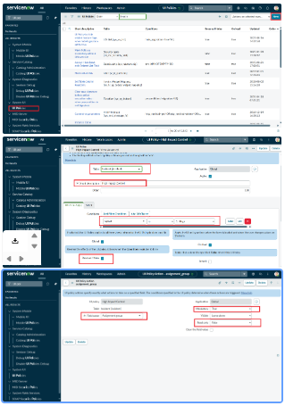
2. | Accuracy  (Test Results) | Test cases executed – 5  Test cases passed – 5  Pass rate (accuracy) – 100%  1. Mandatory enforcement  2. Successful save  3. Reverse condition  4. List edit blocking  5. Form-based update | 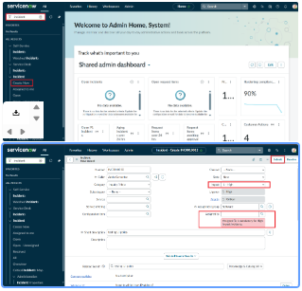  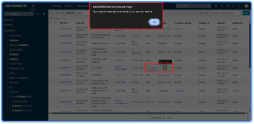  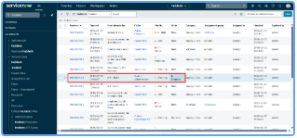
3. | Fine Tunning Result( if Done) | Not applicable – no model was trained, so no fine-tuning was done.

